**DAILY ONLINE ACTIVITIES SUMMARY**

|  |  |  |  |
| --- | --- | --- | --- |
| **Date:** | 8/06/2020 | **Name:** | Krishnitha |
| **Sem & Sec** | 4th sem, A Section | **USN:** | 4AL18CS039 |
| **Online Test Summary** | | | |
| **Subject** | Complex Analysis, Probability and Statistical Methods | | |
| **Max. Marks** | 30 | **Score** | 26 |
| **Certification Course Summary** | | | |
| **Course** | Trailhead Basics | | |
| **Certificate Provider** | Sales Force | **Duration:** | 3 hrs |
| **Coding Challenges** | | | |
| **Problem Statement:**  1) Write a Java Program to check whether the given matrix is magic square or not.  2) C Program to Generate All the Set Partitions of n Numbers Beginning from 1 and so on. | | | |
| **Status:** Executed | | | |
| **Uploaded the report in GitHub** | | YES | |
| **If yes Repository name** | | <https://github.com/krishnitha/Java-coding>  <https://github.com/krishnitha/C-coding> | |
| **Uploaded the report in slack** | | YES | |

**Online Test Details:**

Today we had assessment in the subject Complex Analysis, Probability and Statistical Methods. It was based on second module of this subject. There were 15 questions of two mark each. I scored 26 out 0f 30.

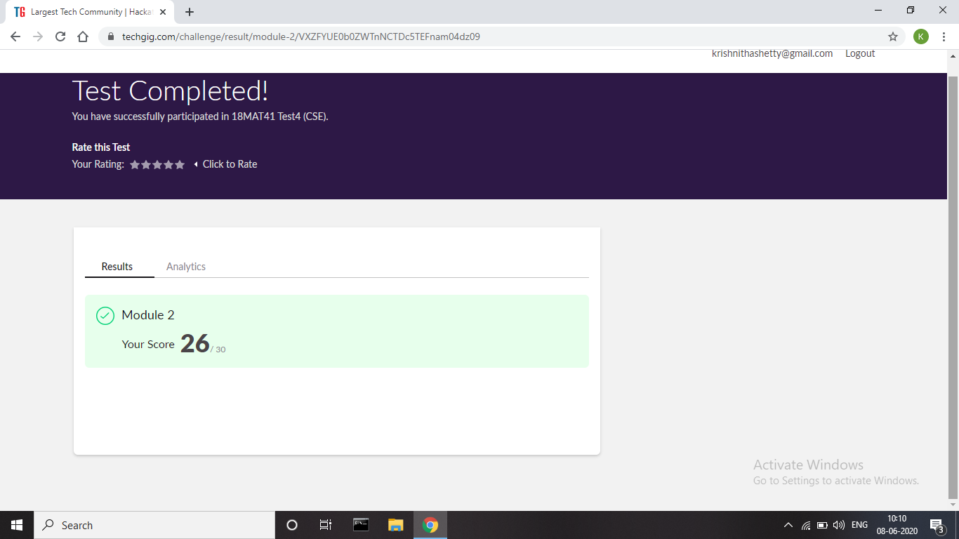

**Certification Course Details:**

Today I have done the Course named Trailhead Basics by Sales Force. Today I have learnt about importing and exporting of the data in the module data management.



**Coding Challenges Details:**

**Problem 1:** Write a Java Program to check whether the given matrix is magic square or not. Given a matrix, check whether it’s Magic Square or not. A Magic Square is a n x n matrix of distinct element from 1 to n2 where sum of any row, column or diagonal is always equal to same number.

**Examples:**

Input:

n = 3

2 7 6

9 5 1

4 3 8

Output: Magic matrix

Explanation: In matrix sum of each

row and each column and diagonals sum is

same = 15.

Input: n = 3

1 2 2

2 2 1

2 1 2

Output: Not a Magic Matrix

Explanation: In matrix sum of each

row and each column and diagonals sum is

not same.

**Step to Follow**

1. Find sum of prime diagonal and secondary diagonal.

2. Calculate sum of each rows and columns.

3. If the prime diagonal and secondary diagonal sums is

equal to every row’s sum and every column’s sum,

then it is magic matrix.

**Solution:** Uploaded it in GitHub

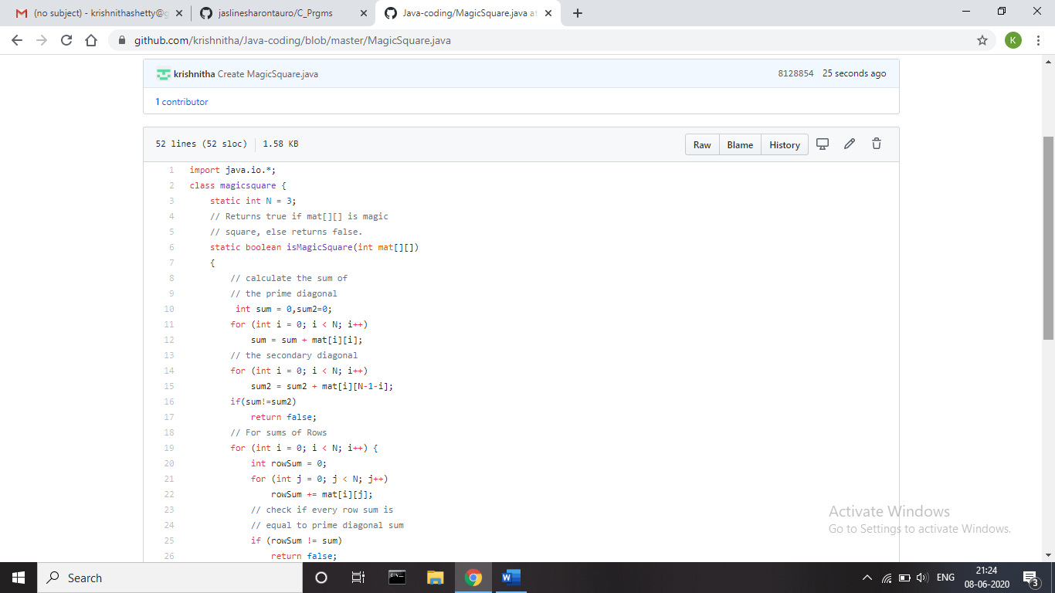

**Problem 2:** C Program to Generate All the Set Partitions of n Numbers Beginning from 1 and so on

This algorithm partitions an integer into numbers which sum

up to form the original number. It generates partitions of a

set of numbers for a given range.

**Sample Input:**

Enter a number N to generate all set partition from 1 to N: 5

Integer partition for 1 is:

1

Integer partition for 2 is:

2

11

Integer partition for 3 is:

3

12

111

Integer partition for 4 is:

4

13

112

1111

22

Integer partition for 5 is:

5

14

113

1112

11111

122

23

**Solution:** Uploaded it in GitHub

